MEDIA RELEASE, 7 December 2023

AFGC to partner with Matthews’ Retailer Engagement Hub at APPEX 2024

The Australian Food & Grocery Council’s Trading Partner Forum (TPF) will partner with Matthews Australasia on a new Retailer Engagement Hub at APPEX 2024.

Matthews CEO Mark Dingley said, “The Australian Food & Grocery Council – or AFGC – is Australia’s peak industry body representing companies that manufacture and supply the nation’s food & grocery products. Matthews has been working hard with industry associations and grocery retailers over four decades towards facilitating a smooth supply chain that delivers on our company purpose and to enable our manufacturing customers to provide their consumers with products safely and efficiently.

“At APPEX 2024, Matthews be hosting a Retailer Engagement Hub, and we’re delighted that the TPF – whose members include major Australian retailers and wholesalers – Coles, Metcash and Woolworths – will be partnering with us on this exciting initiative to benefit all APPEX visitors. We are also proud that the AFGC’s TPF has chosen to partner with us, and recognises Matthews as trusted advisors within the industry.”

Samantha Blake, AFGC’s Deputy CEO, said, “Our vision is for a thriving and trusted industry that sustains the nation, helping members to navigate complex industry issues through information and insights. The TPF’s particular focus is on delivering efficiency improvements across the end-to-end supply chain, that will benefit retailers, suppliers, and shoppers by ensuring the right product is available at the right time and at the right place.

“AFGC will be presenting the TPF’s collective work on the development of the Common Delivery Guidelines for Industry at the Retailer Engagement Hub with Matthews at APPEX. We are delighted to share these resources, which cover guidelines looking at delivery and data integrity among others.”

The TPF Executive Committee comprises members from leading Australian retailers and manufacturers, including Woolworths, Coles, Metcash, Simplot Australia, Primo Smallgoods, Nestle Australia, Sabrands and AFGC, along with New Zealand’s Foodstuffs North Island Ltd and Progressive Enterprises Ltd.

Mark Dingley said, “Manufacturing industry education is also a value and purpose that Matthews shares, as evidenced through the assets we have built in our iDSnet Cloud and two Barcode Learning Centres, one of which is dedicated to 2D barcodes.

“We’ll be able to announce more exciting details early next year, but as an overview, the Retailer Engagement Hub will cover supply chain, labelling and coding, including a 2D barcoding focus, with expert session speakers from leading enterprises covering a variety of subjects over the course of the four-day show.”

The Retailer Engagement Hub will be co-located on Matthews stand, C045 at APPEX 2024.

---

Media contact:
Alex Kelly, Marketing Manager, Matthews Australasia. T: 1300 CODING
AKelly@matthews.com.au

Written by:
Samantha Schelling, for Matthews Australasia, 0431 015 904, samantha@thewordco.com.au

Images:
(hi-res attached of thumbnails below)

Matthews_Retailer Engagement Hub at APPEX_Dec23_Sam Blake-AFGC.jpg
Caption:
Samantha Blake, Deputy CEO of the Australian Food & Grocery Council, said AFGC is delighted to share its Trading Partner Forum resources when partnering with Matthews’ Retailer Engagement Hub at APPEX 2024.

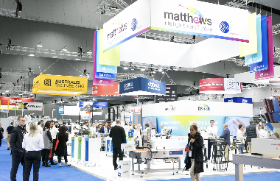 Matthews_Retailer Engagement Hub at APPEX_Dec23_0201.jpg
Caption:
The Australian Food & Grocery Council’s Trading Partner Forum will partner with Matthews Australasia on a new Retailer Engagement Hub at APPEX 2024.

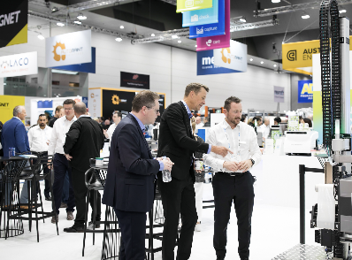 Matthews_Retailer Engagement Hub at APPEX_Dec23_0080.jpg
Caption:
Matthews CEO Mark Dingley said manufacturing industry education is a value and purpose that Matthews shares with AFGC, as evidenced through the assets the coding and labelling specialist has built in its iDSnet Cloud and two Barcode Learning Centres.

END

